Lessons on running a big interactive Zoom meeting:
Reflections on planning and running
the Charities Research Involvement Group meeting
on 18th March 2020

This paper tries to summarise what we did to plan for and run a meeting of people working in charities to support involvement in research, and the lessons we learned. Meetings of the Charities Research Involvement Group normally take place four times a year and up until now have always been face-to-face. We normally have 35-40 attendees.
We used the Zoom Pro account to run this meeting.

Planning the meeting
Have someone who understands the Zoom technology and what it can do and is enthusiastic and committed to running an interactive meeting to help you. Don’t make this person the chair of the meeting, but instead ask them to be on hand during the meeting to provide support. If you need to capture notes from the meeting, appoint a third person to do this role.
Meet with the Zoom expert and the meeting chair over Zoom, to discuss the agenda and how you can run it with maximum interaction. Take time to try out the things you want to do (e.g. putting people into breakout rooms, running a poll) during this meeting.
Make the chair and the Zoom expert meeting hosts.
Think about the maximum time you can run for online, and allow for a break at least every 1-1.5 hours.
Think about using the different options on Zoom to make the meeting work well for everyone, not just because they look fun. So we planned 3 breakout sessions, one poll and one use of the whiteboard for a meeting that would have lasted 4 hours face-to-face.
Develop an annotated agenda with clear notes about what will happen when (our annotated agenda is attached – we shared this between the three of us as a google doc so that we could all update it as planning progressed). Make sure you clearly mark when you are going to move people to breakout rooms, have a poll etc.
Give clear instructions about how to join a Zoom meeting and stress that it’s free to join. The instructions Parkinson’s UK sends out are attached. Don’t assume everyone is already using Zoom. They aren’t.
Encourage people to join via their computer (not their phone) if at all possible. This means that you can see who is in the meeting (if people join by phone you seem to only see their phone number, not their name). But don’t exclude people who can only join by phone.
Send out the agenda in plenty of time, along with joining instructions, so that people have time to ask questions. Make the Zoom link live as soon as you post the agenda so that everyone can try it out beforehand if they want, and tell people they can do that. In future we will also send out any slides in advance so that people who need to join by phone can still follow presentations.
We asked a small group (about 8 people) who are ‘senior’ (i.e. they attend these meetings regularly and often volunteer to take on tasks such as chairing) to support us on the day by making sure that small groups run well (e.g. acting as notetakers, making sure everyone had a chance to speak). We felt this really paid off in the meeting, as all of the small group discussions (see the ‘breakout rooms’ section below) worked well.
We briefed the speakers and explained to them about sharing their screens. We also asked them to send us their slides in advance so that we could share our screens instead if there were problems.
We were surprised by how many people said they wanted to come to the meeting. We had 4 apologies and 44 people planning to attend – maybe people want the contact when they are working from home? We would normally have about 8 apologies.
We put together some instructions for the chair to go through at the start of the meeting and again as we split people into groups to explain how we would use Zoom. See our briefing for these.
Polls
If you want to include a poll in the meeting you need to set this up beforehand on the Zoom website (https://zoom.us/) - you can’t do this within the actual meeting. Similarly, if you want to edit the options in a poll, you need to do this on the website before launching the poll in the meeting. You seem to be able to have 10 options within a poll.
Whiteboard
You can activate the whiteboard feature at any time using the ‘share screen’ button. We didn’t use the whiteboard in the end on this call - but plan to ensure we know who can add to it if we do so in future, as we struggled with this in our planning.

During the meeting
41 people joined the meeting. Some came in and out, but almost all stayed for all of it. At the beginning of the meeting Annie (the chair) ran through instructions for using Zoom (see the briefing).
It’s particularly important to ask people to mute when not speaking to limit background noise and to remind people to unmute when they want to speak. Lots of us forgot to unmute on several occasions.
Introductions
We decided to make time for each person to introduce themselves, as we do this in our face-to-face meetings. We tried to get everyone to be brief. Another option might be that people introduce themselves when they start speaking - but this might make discussion more stilted and people might forget to do it.
Don’t use the list of participants (on the Zoom task bar) to get everyone to introduce themselves - the person who’s speaking jumps to the top of the list (after the host) each time someone speaks, so it’s very hard to work down the list.

Zoom names
As part of the introduction we should have asked people to add their organisation to their Zoom names, as it would have helped everyone to identify people. People can do this by clicking on the participant tab at bottom and then hover over their own name. A ‘rename’ button appears.
Using the ‘gallery’ function
We encouraged people to switch to the gallery function so that they could see other people on the call, rather than just the speaker. In hindsight we realised that there were too many people on the call for us to see everyone in the gallery. We should have been clear about this, so that people could choose to stick with the ‘speaker view’ function if they wished.
Using the ‘breakout rooms’ function for small group discussions
We decided to randomly allocate people to ‘rooms’ during the meeting for small group discussions, as we wanted some of the topics for discussion to be generated as part of the meeting. Normally in our face-to-face meetings people will choose which small group they go to, so we had to be ready to tell people that they wouldn’t have a choice about which group they were allocated to. (Note: it is possible to allocate people to specific rooms on Zoom, however given the number of people on this call it would have been very time consuming to do this. Note also that you need to have enabled the breakout rooms function in your Zoom account to set up breakout rooms. This is free of charge within the Zoom pro package and is not the same as what Zoom calls ‘conference rooms’.).
We used six rooms for each breakout session, as we felt any more would make feedback too long. The maximum number of rooms you can have is 50. You can choose how many people you allocate to each room.
You can name the rooms (with the category/topic for that room) at the start of the meeting/in a break/whenever you have a minute to spare - this will save you doing it when you actually want to send people into rooms. You can also change the options so that people are either invited to a room or sent there automatically.
Participants in breakout rooms can request that the host join their room by clicking ‘Ask for Help’. Hosts can also broadcast messages to all rooms - we used this to give a 5 minute warning. Keep the broadcast message short as it only seems to display a limited amount of text. And hosts can go into rooms to see how the discussion is going.
When people are in breakout rooms, the ‘main room’ is still running (although it will be empty unless anyone chooses to exit back to the main room). If new people join the call, they will enter into the main room, and will only be able to join a breakout room if the host allocates them to one. We made sure one host was always in the main room to welcome people who joined late or who re-joined the call.
Using the ‘chat’ function
Lots of people used the ‘chat’ function to tell us if they needed to leave the meeting or to express agreement or support for something that was said.
We used the chat function regularly to tell people that if they joined the meeting late they may not see many participants as they would be in rooms. 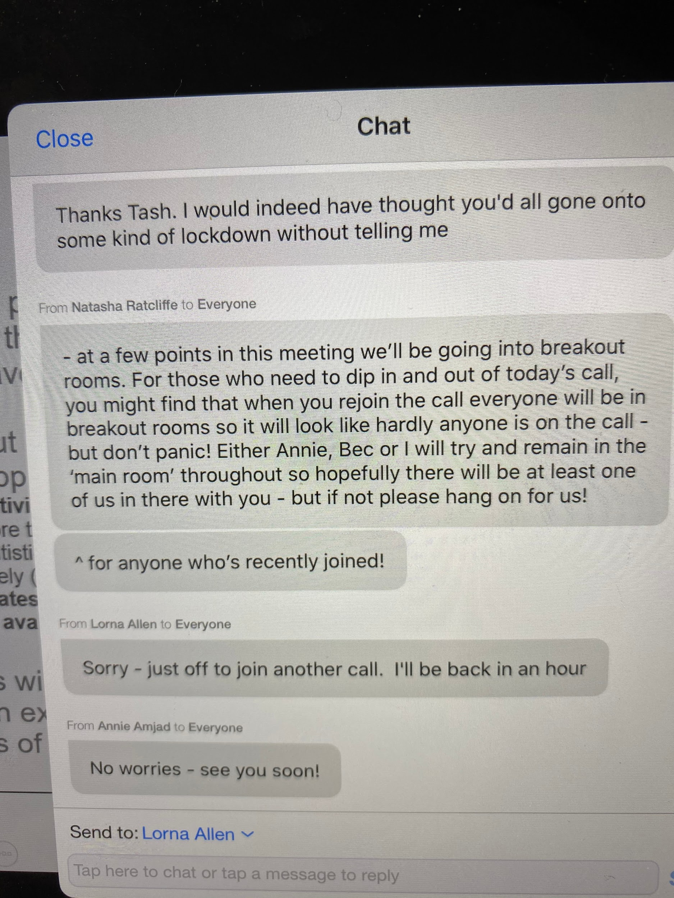
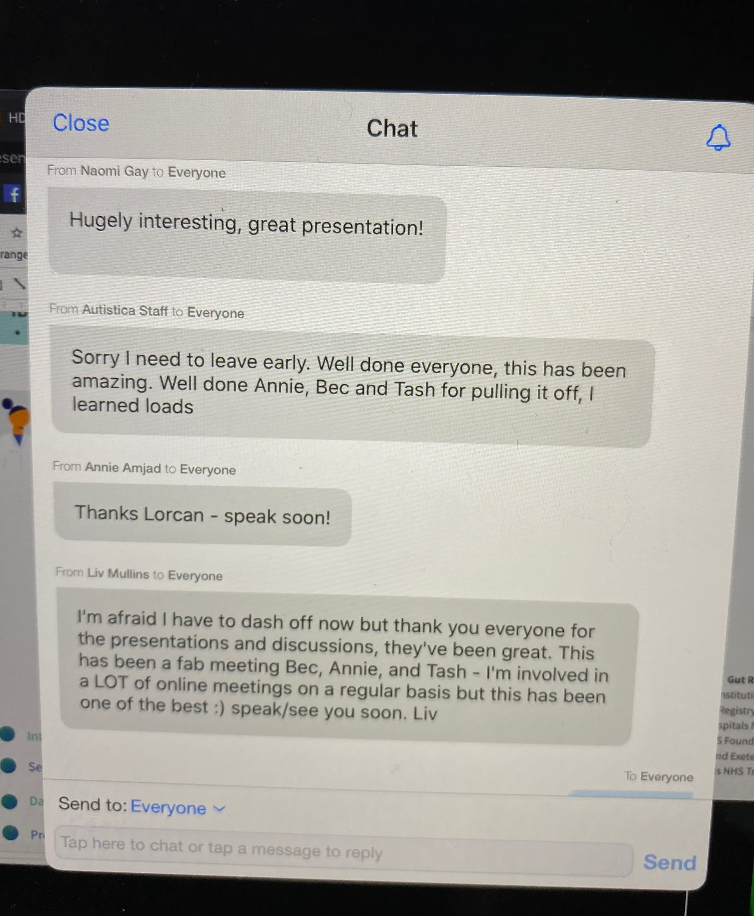
As hosts it was really useful to be able to chat throughout the meeting about things like timings, changing how we were running a particular item etc. Make sure you’re messaging someone ‘privately’ if you want to do this.
You can also use the chat function to get people to put up their hands if they want to speak. We didn’t use this but may in future if we find lots of people are trying to speak at once.

Meeting duration
We finished the meeting in 3.5 hours, including one 10 minute break. This was too long. We think a maximum of three hours would work better, with at least one 10 minute break.

After the meeting
We sent everyone an email immediately after the meeting and asked them for their views on how it had gone as a virtual event. Feedback was universally positive. The main suggestion for next time was that we shorten the meeting.

Annie Amjad, Natasha Ratcliffe, Parkinson’s UK and Charities Research Involvement Group
Bec Hanley, Charities Research Involvement Group
www.slginvolvement.org.uk
March 2020

Parkinson’s UK’s instructions on how to join a Zoom meeting

Joining a Zoom meeting

1. Click on the Zoom link you have been sent by email or meeting invite (it will
look something like: https://zoom.us/j/9053434)

Joining from a mobile or tablet (e.g. iPad)
If you are joining from a mobile or tablet, you will be prompted to download the
Zoom Cloud Meetings app from the App/Play Store after you click the meeting link.
See here for more details.

Joining from a computer
When entering a Zoom meeting for the first time from a computer you will need to download a small application file.
This process is easy to complete on most browsers. When you click the meeting link, you will be prompted to download the file (Google Chrome should automatically download the file).
Then click on the Zoom_launcher.exe file to launch Zoom. In Google Chrome this should appear in a bar at the bottom of the screen, in other browsers you may need to click on your Downloads.
Just before entering the meeting you will be prompted to enter a display name.

Join Audio by Computer
You will then be asked how you wish to join your audio. Select Join Computer by Audio.

Join by Telephone
If you are unable to join from Zoom on a computer or mobile, then you can join on the telephone instead.
Call: 0800 260 5801
Enter the Meeting ID (which can be found in the email or invite) when prompted

Another way to join a Zoom call is to:
2. Go to zoom.com/join and Enter the Meeting ID (9 or 10 digit number) that you
have been sent by email or meeting invite and click ‘Join’

Charities Research Involvement Group
Meeting on 18th March 2020
BRIEFING FOR ANNIE

- Welcome, introductions and apologies 1.15 – 1.35pm
- Welcome everyone to this meeting, especially guests and new members (I’ll give you a list)
- This is the 1st time we’ve used Zoom for such a big meeting, and the CRIG has never met virtually before - so please be patient and please send feedback at the end about how you felt it went.
- Give some explanation about how the meeting will work by zoom, especially how the small groups will work
    - There’a a task bar somewhere on your screen - it’s in different places on different computers - try hovering over the screen if you can’t see it. The task bar gives you the option to mute, to ask a question and to share your screen
    - We ask you to mute if you’re not speaking. Don’t forget to unmute if you want to speak!
    - Try using the ‘gallery view’ (rather than ‘speaker view’) option (the button is probably at the top of your screen) to see who is on the call.
    - At different points in the meeting we’ll be splitting into groups. This means that you'll be randomly allocated to a ‘room’. Sorry you can’t choose which room you go into. In your room, please make sure you know who everyone is (those who have dialled in will need to say who they are) and make sure that someone is taking notes so that they can feed back. We’ll remind you about this again when we split you up.
    - If you’re struggling with the technology at any point, please send a message to Natasha Ratcliffe and she’ll do her best to help you.
- Get everyone to introduce themselves – their name, job title and organisation and to mention one thing they’re working on related to patient and public involvement in research at the moment
    - Annie to read out names for intro order
- Run though any apologies – again I’ll bring a final list with me on the day
- Check what time people need to leave – the scheduled stop time is 5.00pm but we are hoping to finish before that as we know it’s harder to stay focused in an online meeting.
- Check whether people have any ‘any other business’ to raise at the end of the meeting. Paula and David (guest from NIHR) will share info about the INVOLVE move under this item.

- Update on actions agreed at our meeting on 9th December 1.35 – 1.50pm
The meeting notes were circulated with the papers for this meeting. I’ve sent you a copy to the end of this briefing. I’ve highlighted the actions that I suggest you pick up on – these are also listed below:
- Item 2: Ask Bec to give an update on behalf of the Pharma Working Group on their meeting last week.
- Item 2: Ask Jenny Robertson to report back on the train the trainers workshop held on 16th January
- Item 8: Ask Jenny if she has managed to make a list of accessible meeting venues.
Others actions are either on the agenda or are actioned/in process.

Working with vulnerable/hard to involve groups and how to involve them well 1.50 – 3.20pm
- Explain how this agenda item will work. We’ve got two presentations, then we’ll move to some group discussions.
- Explain that Anita VanMil, how was due to talk about involving people as peer interviewers, has had to send her apologies.
- Ask Anna-Louise Smith to talk about the involvement of people with dementia in the Alzheimer’s Society’s Research Network. (NO SLIDES)
- Encourage questions
- Ask Bethan Davies to talk about how Autistica involves autistic people in research. Remind Bethan to share her screen
- Encourage questions
- Ask everyone to shout out the kinds of people they want to involve, or they want to involve better and make a list (poll)
  - Annie to set up and administer poll
- Make each of these a room BREAK OUT ROOMS
  - Annie to split people into rooms, name breakout rooms based on topic areas
  - Bec to remain in main room for entire discussion
  - Reminders:
    - Check you know who everyone is in the room - people joining by phone may need to say who they are as only their phone number will show up.
    - Appoint one person to share feedback.
    - And that people will have 1 min countdown when we return to main room to wrap up convo
    - Can request the host to join the room if there’s any problems, or post a message to Tash.
- The task for each room is to address three questions (Annie to post in broadcasting chat):
  - How would you (have you) found these people?
  - How would you/have you involved them well?
  - Come up with three top tips to share
  - Allow about 15 minutes for this discussion
  - Annie - enter each room at start of discussion to check
  - Annie - post 5 min reminder using broadcasting chat to all rooms, ask groups to appoint one person to feedback
- Ask each group to feed back

Have a short break here

- What topics do we want to cover in 2020/21? 3.20 – 3.45pm
- Put people into rooms – ideally different ones from the groups in the previous agenda item. Give them 10 minutes to come up with a list of topics they would like to discuss next year.
- BREAKOUT ROOMS
  - Annie to split people into rooms
  - Get each group to feed back.
  - Tash to share whiteboard screen and write feedback live
- Explain we’ll poll everyone to get their top choices after the meeting and then the Continuity Group will come up with a workplan

- PPI in big data research 3.45 – 4.15pm
- Explain we’ve got two speakers and then we’ll spend some time in groups
- Welcome back Sinduja Manohar – she was at British Heart Foundation but has now moved to Health Data Research UK. She’ll talk for about 10 minutes. Remind Sinduja to share her screen
- Then encourage questions
- Ask Nikul Bakshi to talk about how Crohn’s and Colitis UK is involving people in big data research. Tash to share Nikul’s slide
- Then encourage questions
- BREAKOUT ROOMS
  - Annie to split people into rooms, reminder to appoint 1 person to give feedback
- Then move people into rooms. Ask people to discuss three questions (Annie to post questions in broadcasting chat):
  - What’s your experience in this area?
  - How confident would you/do you feel about involving people in this type of research?
  - Are you interested in the CRIG doing something about involvement in this type of research? If so, what? (e.g. some guidance, collect case studies, an event)
- Give people about 10 minutes
- Run some feedback
  - Tash to do the whiteboard thing again to capture feedback?
- Thank the speakers, especially Sinduja.

- Time for any member to ask a question or raise an issue they’d like to discuss 4.15 – 4.45pm
- Explain that we want this Group to offer informal support to people. So we have a standing agenda item at each meeting, where members can ask a question or raise an issue they’d like to discuss.
- Ask everyone if they have a question or an issue they’d like to discuss. If so, ask them to briefly explain what it is before we get into discussing them.
- Discuss each question as a whole group, in turn. Get the questioner to explain their question in a bit more detail first.

- Any other business 4.45 – 4.50pm
- Hopefully you’ll know if anyone has anything else they want to raise.

- Plans for our next meeting 4.50 – 5.00pm
- Remind everyone that our next meeting will be on 30th June, from 1pm – 5pm at BHF, or online, depending on the situation with Coronavirus.
- We’ll ask for a volunteer to chair the meeting when we know whether we’ll be meeting face-to-face or online.
- That’s it! Thank everyone for coming and ask people to email Bec with feedback about how the meeting went and what we could do to improve it, as it was our first virtual event – in case we need to hold the June meeting virtually too.

